Infosys Springboard Virtual Internship 6.0

Completion Report

Batch Number: 6

Start date: 27/11/25

Name: Radhika Sharma

Internship Duration: 8 Weeks
1.Project Title
AI-Based Intelligent System for Skin Disease Detection and Healthcare Recommendation

2. Introduction

Skin diseases are common health issues that require early diagnosis and timely treatment. However, access to dermatologists is limited, especially in remote and underserved areas. This project focuses on developing an AI-based intelligent system that assists users in detecting skin diseases using image analysis and provides healthcare recommendations.
3.Project Objectives
• Lack of early and accurate skin disease diagnosis

• Limited access to dermatologists

• Difficulty in finding nearby specialized dermatology clinics
4.Project description in detail
• Classify skin diseases using AI-based image classification models

• Assist users with healthcare recommendations based on prediction results

• Help users locate nearby dermatology clinics using location-based services

The system integrates location-based services to recommend nearby dermatology hospitals using real-time geographic data. A user-friendly web interface was developed to ensure smooth interaction, allowing users to upload images, view predictions, select location preferences, and explore nearby hospitals.

5.Technologies Used:
- Frontend: React.js, Tailwind CSS
- Backend: FastAPI , Python
- AI/ML: CNN model using TensorFlow, Clip-based model - SkinClip
- APIs: Google Places API
- Database: Supabase , postgresql
- Deployment & Tools: GitHub, REST APIs
Real-World Impact:

The system provides an accessible and scalable solution for preliminary skin disease assessment, especially beneficial in areas with limited access to dermatologists.

6. Timeline Overview
Week | Activities Planned | Activities Completed
Week 1 | Dataset collection from Kaggle and initial exploration | Collected labeled skin disease dataset
Week 2 | Data cleaning, preprocessing, and dataset splitting | Cleaned data and split into train, validation, and test sets
Week 3 | Model architecture design and implementation | Implemented CNN and Clip-based skin disease classifier
Week 4 | Model training, optimization, and evaluation | Trained model using Adam optimizer and evaluated accuracy
Week 5 | UI exploration and hospital recommendation planning | Explored Streamlit and designed UI workflow
Week 6 | UI integration and feedback mechanism | Integrated image upload, prediction, and hospital recommendation
Week 7 | System testing and bug fixing | Tested complete system and resolved issues
Week 8 | Documentation and final presentation | Prepared project report and presentation

7.. Key Milestones
Milestone | Description | Date Achieved
Project Kickoff | Dataset collection | Week 1
Prototype/First Draft | Cleaned dataset and Pretrained model | Week 3
Mid-Term Review | ML model + backend + frontend + Google Places integration | Week 6
Final Submission | Completion of the Web Page | Week 7
Presentation | Final Demo of App features | Week 8

5b. Project Execution

Phases built upon the technical validation are as follows: -
1. Data Foundations & Model Training
Data preprocessing involved cleaning and augmenting datasets (e.g., resizing images, normalizing pixel values) to ensure consistency. Model training was an iterative loop: adjusting hyperparameters and architectures until the prediction accuracy met the threshold required for a specialized medical-use case.
2. Backend API Development
Once the model was performant, it needed to be "exposed" so other services could be applied
- Model Wrapper: FastAPI was used to wrap the model. The API takes user input (like uploading an image), passes it to the model, and returns a JSON response with the prediction and confidence score.
- Decoupling: By building APIs, the frontend doesn't need to knew how the ML model worked; it just needed to know how to call the endpoint.
3.UI/UX Design & User Interaction
With the logic in place, the focus shifted to the user's journey.
- Functional Design: The UI wasn't just about aesthetics; it was about utility. This involves creating intuitive upload buttons, clear result displays, and progress indicators (spinners) to manage user expectations while the model processes data in the background.
- Responsiveness: Ensuring the interface works across mobile and desktop, as most users seeking quick medical info or hospital locations are on mobile devices.
4. Location Services Integration
This added a layer of "Actionable Intelligence" to the app. A prediction is only helpful if the user knows where to go next.
- Geospatial Queries: Using APIs like Google Places Integration , the system captures the user's coordinates (with permission).
- Dynamic Fetching: The backend queries a database or a third-party API (Supabase) to find "Dermatology" tagged facilities within a specific radius (e.g., 10km) of the user.
- Testing, and Debugging
Iterative development thrives on the Feedback Loop.
- System Reliability: You likely performed Integration Testing to ensure that if the Location Service failed, it didn't crash the ML prediction results.
- Edge Cases: Debugging likely covered scenarios such as low-quality image uploads, users denying location permissions, or high-latency network connections.
- Refinement: Based on initial testing, you might have gone back to step 1 to retrain the model on specific cases it missed or adjusted the UI to make it more accessible.
8. Snapshots
Code Snippet: -

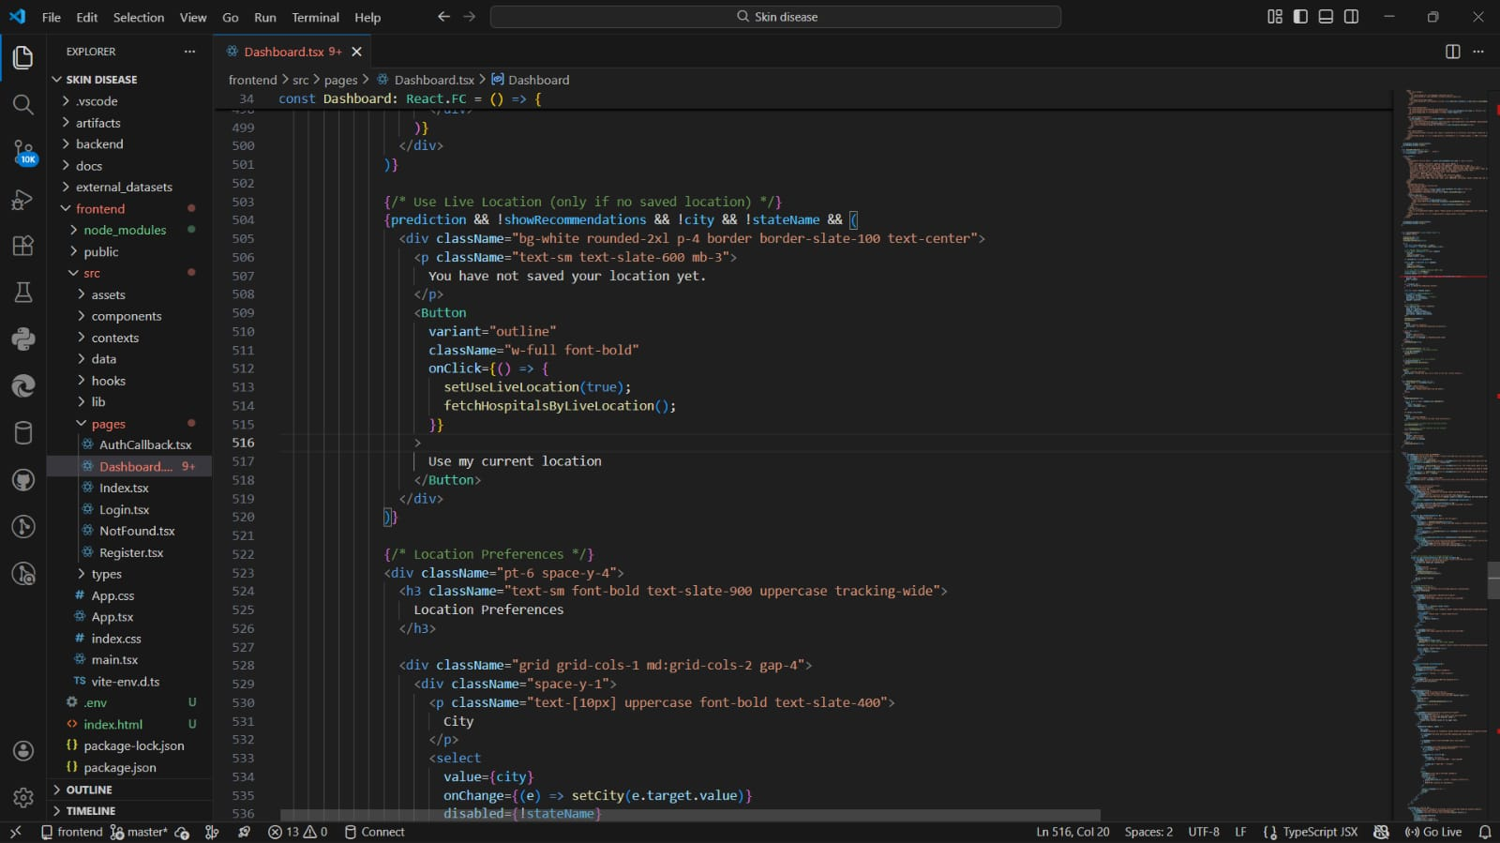

WEB APP:-

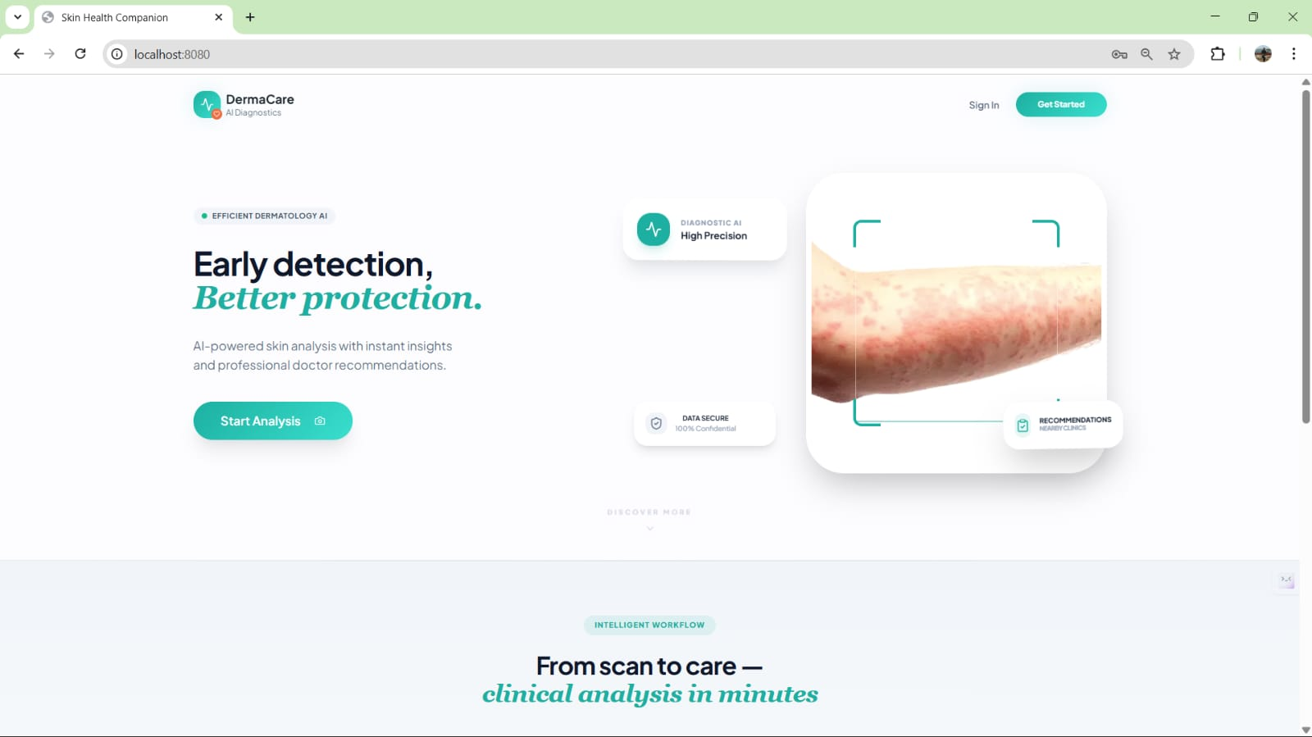

Login & Sign In

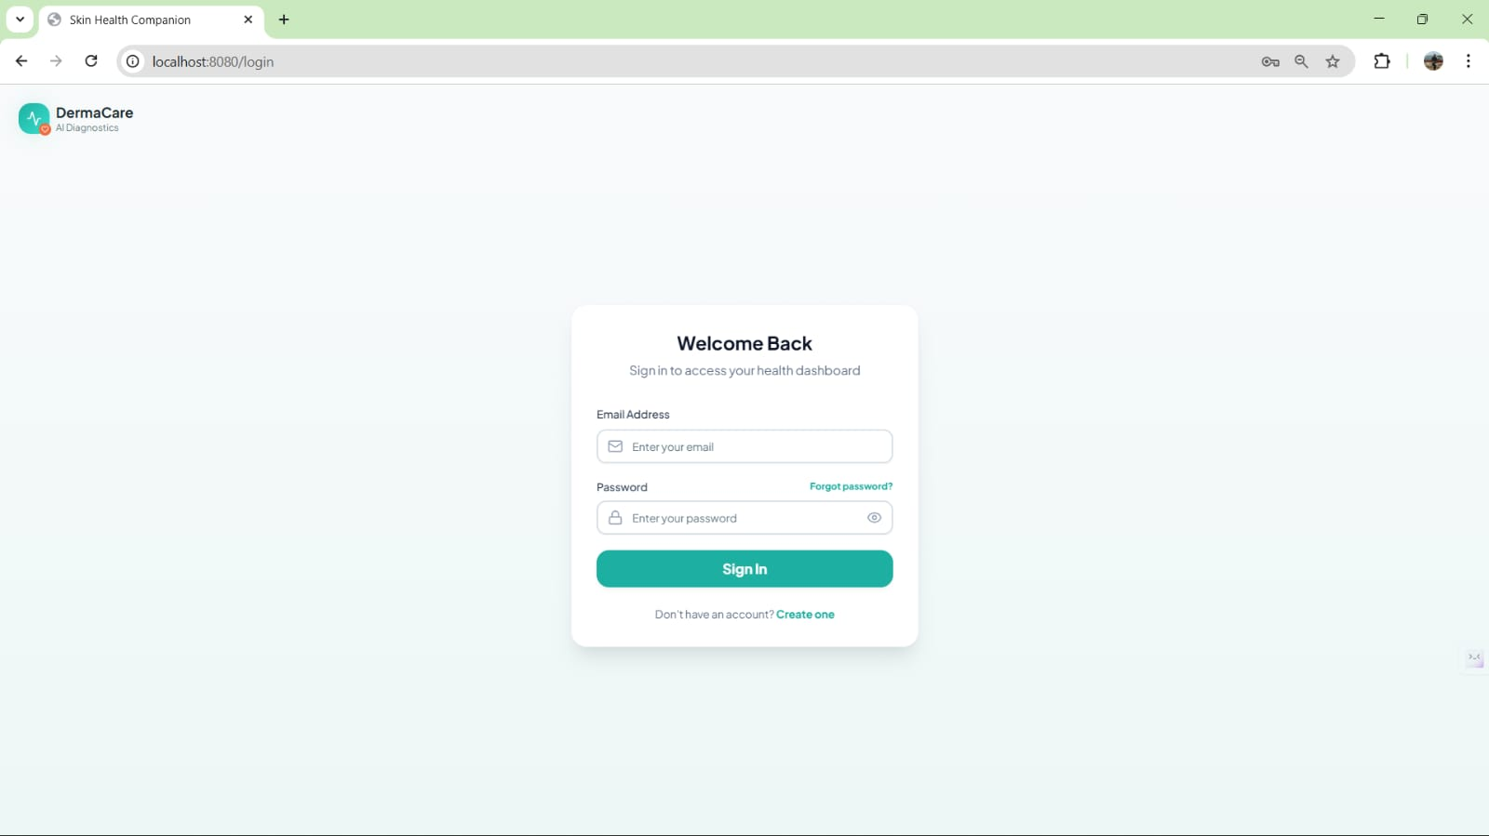
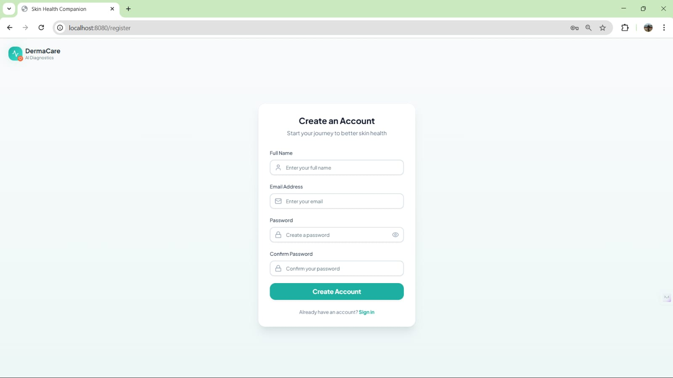

Homepage

User Profile
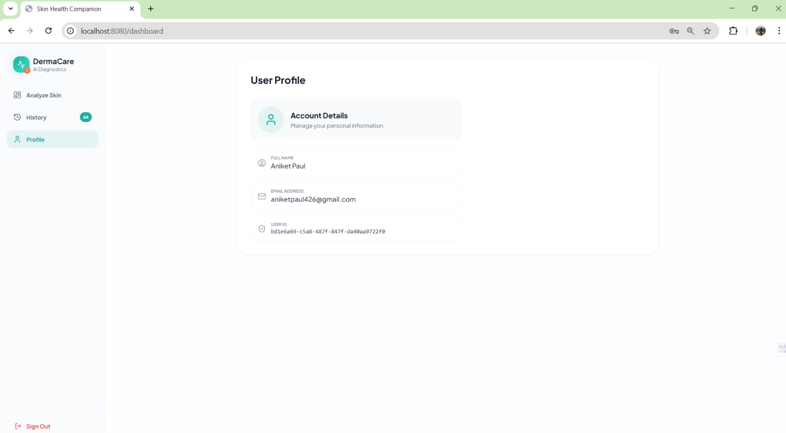

User interface

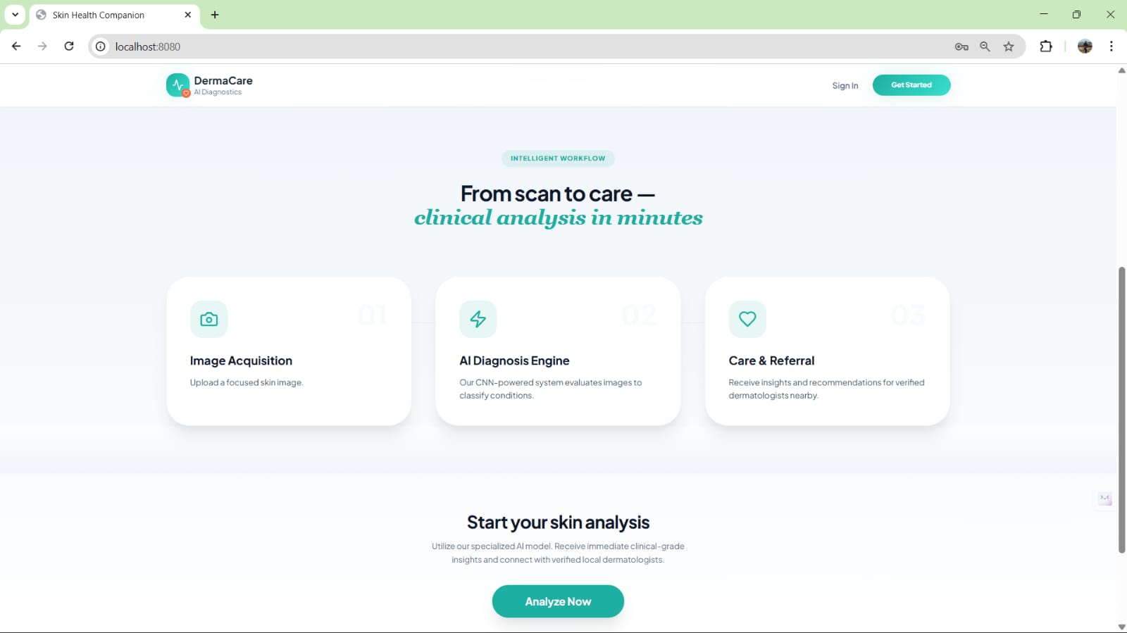

Detailed Analysis Of The Disease

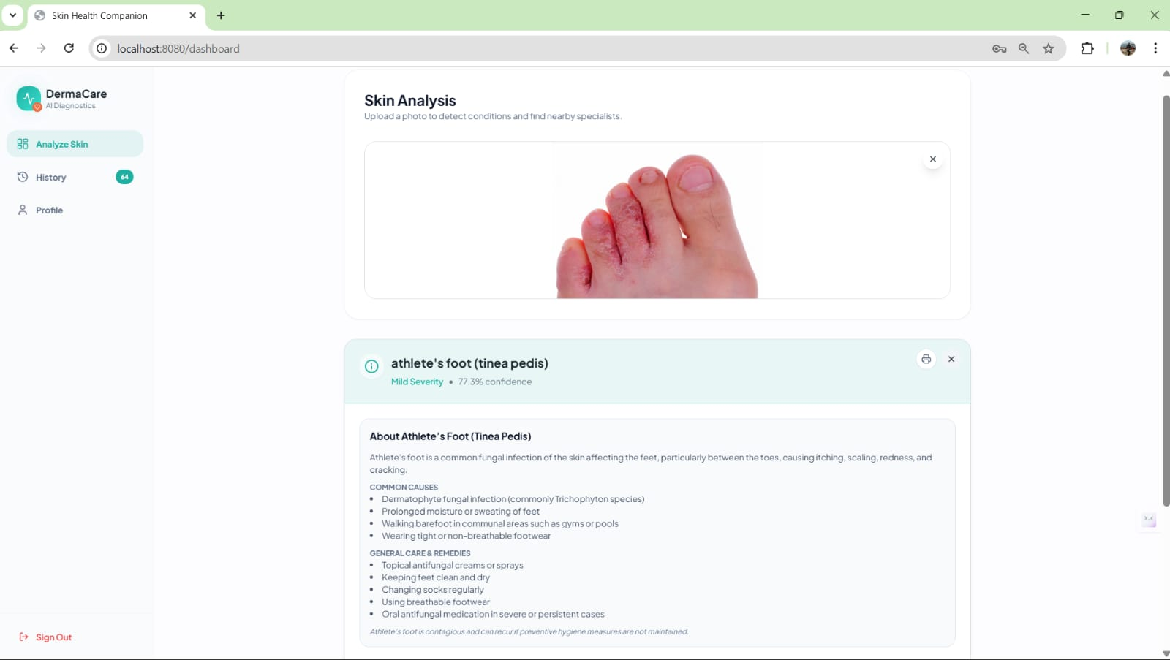

Nearby dermatology support suggested based on user location

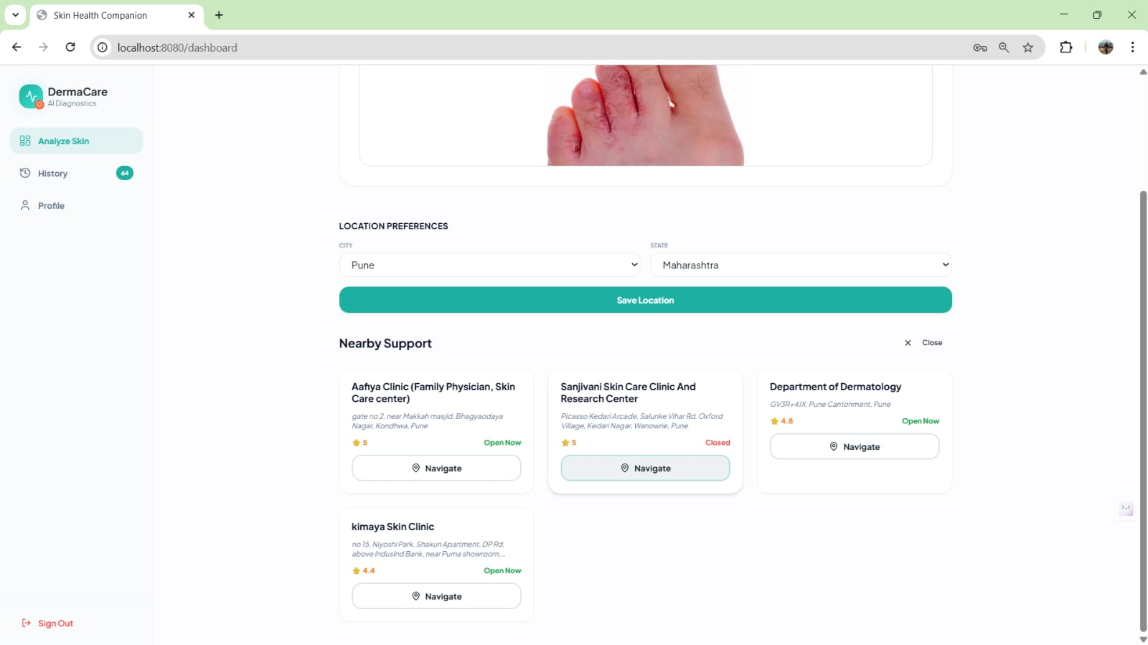

Details of the selected hospital

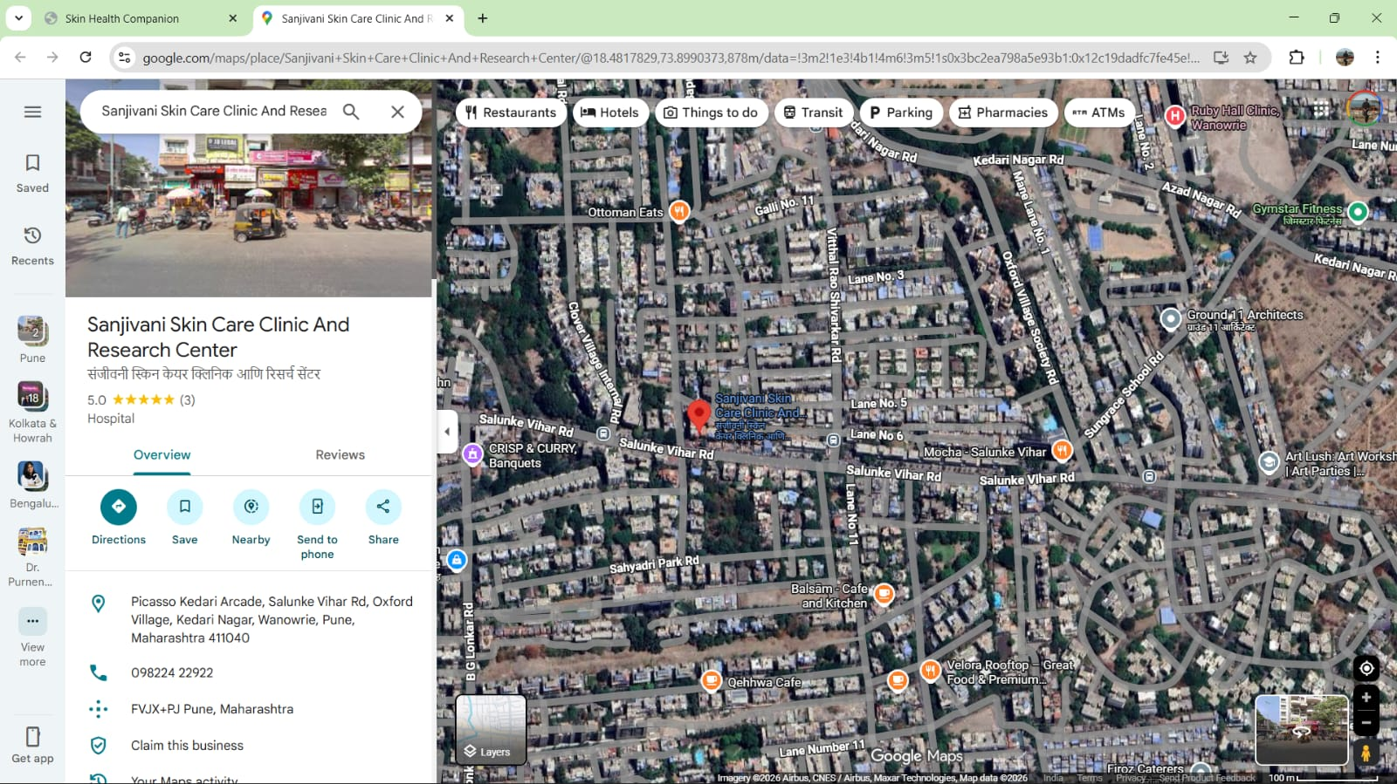

Clinical Analysis Report

History
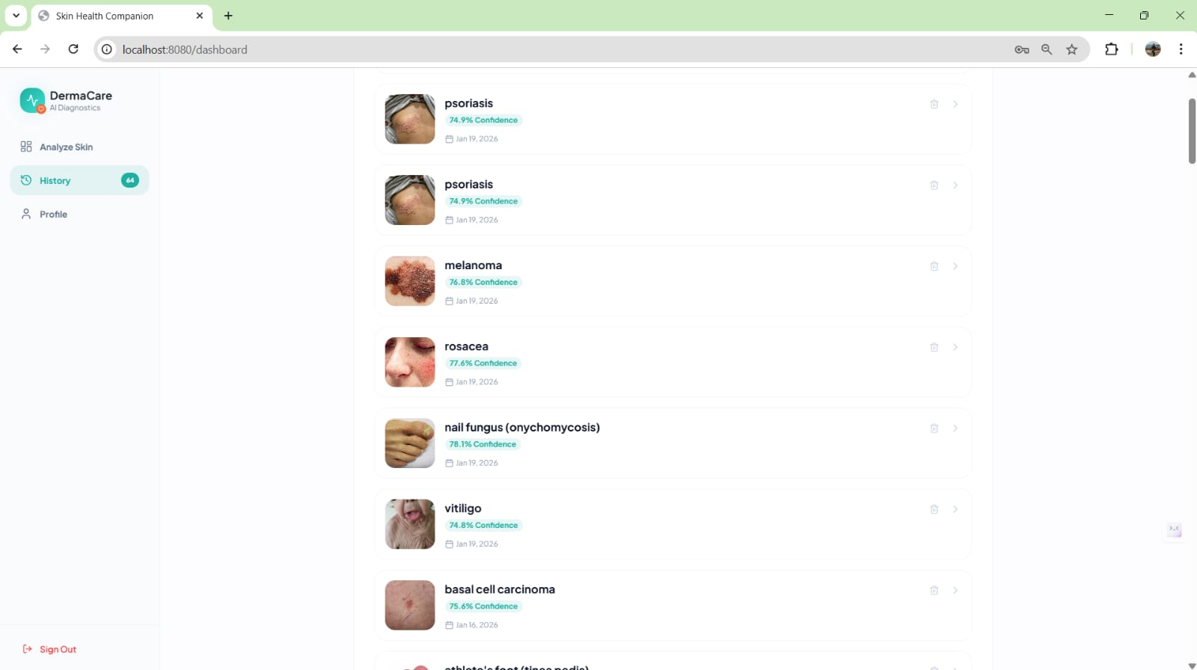

9.Challenges Faced
- Low Confidence Scores due to Unbalanced Dataset
Some skin disease classes had very few training images, leading to low prediction confidence.
Mitigation:

Applied data augmentation techniques to balance the dataset and improve model confidence.
- Poor Generalization Beyond Trained Classes
**The model struggled to accurately detect skin conditions outside the trained categories.
Mitigation:

**Improved feature extraction and used regularization techniques to help the model generalize better to unseen skin patterns
- Inaccurate Hospital Results Based on Location
Hospitals were not updated correctly when the user changed city or state.

Mitigation: We decoupled skin analysis from location logic and implemented dynamic hospital fetching using city or state-based APIs, ensuring hospitals update automatically without re-analysis.
- API & Location Integration Issues
Geocoding failures and missing API keys caused empty hospital results**.**

Mitigation:

We properly configured environment variables, added fallback error handling, and validated API responses to ensure stable location-based data retrieval.

10. Learnings & Skills Acquired

Technical Expertise
- Deep Learning & Optimization: Mastered the iterative cycle of model training, hyperparameter tuning, and data augmentation to achieve high-precision results for complex diagnostic tasks.
- Backend Engineering (FastAPI): Built high-performance, asynchronous REST APIs to serve ML models, focusing on efficient data validation and low-latency inference.
- Modern Frontend (React & Tailwind): Developed a responsive, component-based UI, utilizing Tailwind CSS for rapid styling and React hooks to manage real-time application states.
- System Integration: Gained proficiency in connecting disparate layers—linking ML outputs to frontend displays and integrating third-party Geospatial APIs for location-based hospital mapping.
Professional Development
- Full-Stack Debugging: Developed a systematic approach to troubleshooting errors across the stack, from API handshake failures to data-shape mismatches in the model.
- Agile Problem Solving: Learned to adapt the project based on feedback, refining the UI and model performance through continuous testing and iterative updates.
- Team Collaboration: Practiced effective communication and version control, ensuring seamless integration between the "intelligence" (ML) and "interface" (Frontend) layers.
11. Testimonials from team
- This internship helped us understand how AI and machine learning can be applied to solve real-world healthcare problems effectively.
- We gained hands-on experience in building an end-to-end skin disease detection system, from data preprocessing to model deployment.
- The project enhanced our teamwork, problem-solving, and debugging skills while working under real project constraints.
12. Conclusion

The AI-Based Skin Disease Detection and Healthcare Recommendation System provided us with hands-on experience in image-based disease classification, deep learning model development, and full-stack web application integration. Through this project, we learned how to preprocess medical image datasets, train and evaluate CNN models, and deploy AI solutions through an interactive web interface. The integration of hospital recommendation based on detected diseases demonstrated how AI can support real-world healthcare decision-making. This project enhanced our technical skills in machine learning, Python, and web development, while also strengthening teamwork, problem-solving, and practical implementation abilities. Overall, it prepared us to apply AI technologies effectively in real-world healthcare applications.

13. Acknowledgements

I sincerely thank Infosys Springboard for providing us with this internship opportunity. I am grateful to my mentor for his continuous guidance, feedback, and support. I also thank the coordinator for smooth coordination and timely updates. Finally, I appreciate the efforts of my team members onkar injare, yashaswini R, Adarsa Vadlamudi, and Shivangi Gupta who worked together, shared knowledge, and helped to successfully complete this project.

